**Top 7 Fintech trends for 2024 and beyond**

[[Pragmatic Coders](https://medium.com/@pragmaticcoders?source=post_page-----9472b9631e0d--------------------------------)](https://medium.com/@pragmaticcoders?source=post_page-----9472b9631e0d--------------------------------)

[Pragmatic Coders](https://medium.com/@pragmaticcoders?source=post_page-----9472b9631e0d--------------------------------)

·

[Follow](https://medium.com/m/signin?actionUrl=https%3A%2F%2Fmedium.com%2F_%2Fsubscribe%2Fuser%2F55a91844df5c&operation=register&redirect=https%3A%2F%2Fmedium.com%2F%40pragmaticcoders%2Ftop-7-fintech-trends-for-2024-and-beyond-9472b9631e0d&user=Pragmatic+Coders&userId=55a91844df5c&source=post_page-55a91844df5c----9472b9631e0d---------------------post_header-----------)

7 min read

·

Oct 13

23

2

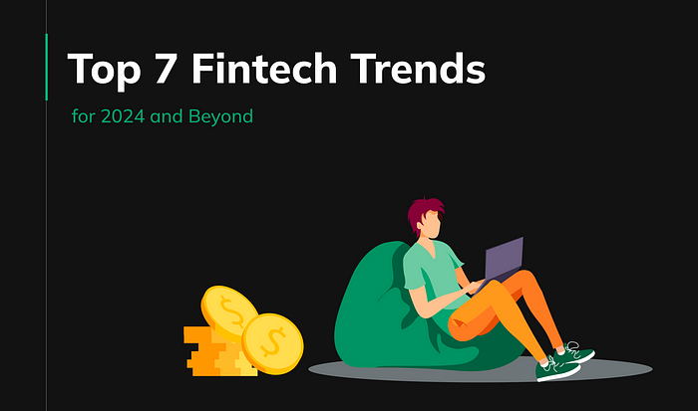

Fintech products are at the forefront of reshaping the financial landscape. They’ve come a long way from simple mobile banking tools to robust platforms and next-gen solutions. The upcoming years are going to bring significant milestones for Fintech initiatives.

**[1 min business newsletter](https://medium.com/@pragmaticcoders/1-min-business-newsletter-c7cbee9a15cb?source=post_page-----9472b9631e0d--------------------------------" \t "_blank)**

[Your dose of knowledge on AI, Product Management, Product Design, Fintech, Healthtech & Agile.](https://medium.com/@pragmaticcoders/1-min-business-newsletter-c7cbee9a15cb?source=post_page-----9472b9631e0d--------------------------------" \t "_blank)

[medium.com](https://medium.com/@pragmaticcoders/1-min-business-newsletter-c7cbee9a15cb?source=post_page-----9472b9631e0d--------------------------------" \t "_blank)

**tl;dr**

* Biometric Authentication: Fintech products will increasingly use facial recognition and fingerprint scanning for secure and convenient user authentication.
* AI-Powered Personal Finance Advisors: AI-driven advisors within fintech apps will offer tailored financial advice, including budgeting, investing, and debt repayment.
* Stablecoins:These digital currencies will bridge the gap between traditional and digital money, offering transparency, efficiency, and global reach.
* Neobanking Applications: Neobanks, with their convenience, affordability, and innovation, will continue to expand, providing a competitive alternative to traditional banks.
* Blockchain Integration: Blockchain technology will enhance security, reduce costs, and improve efficiency in fintech solutions, particularly in areas like cross-border payments, lending, and trade finance.
* Embedded Finance: Financial services integrated into non-financial products and platforms will offer convenience, affordability, and choice to users.
* Financial Inclusion Initiatives: Fintech companies will focus on making affordable financial services accessible to underserved populations through mobile banking, digital payments, alternative credit scoring, and microfinance.

**Fintech trends for 2024 and beyond**

In this article, we’ll delve into the trends in fintech that will shape the future of the financial industry in 2024 and beyond. We will also discuss how they are poised to revolutionize the way we interact with our money.

**1. Biometric authentication**

Biometric security features like facial recognition and fingerprint scanning are [fast becoming the new norm](https://straitsresearch.com/report/biometric-authentication-and-identification-market). They offer a number of advantages over traditional authentication methods, such as passwords and PINs:

* **Convenience:** Biometric authentication beats traditional methods with its simplicity. Just scan your face or fingerprint, saving time and hassle, ideal for frequent fintech app users.
* **Security:** Biometric authentication offers enhanced security compared to traditional methods. Unique biometric features are very hard to replicate. Thus, they greatly reduce the risk of unauthorized access to your fintech account and financial data.
* **Privacy:**Passwords and PINs can be compromised in various ways. However, with biometrics, your data is securely stored on your device and used exclusively for authentication. This makes it a far more privacy-friendly option than traditional authentication methods.

Imagine logging into your fintech app with a glance or a touch — it’s not science fiction anymore; it’s a real fintech trend. Your unique physical traits are your keys to financial security. In 2024, an increasing number of fintech products will require you to utilize these keys. With biometric authentication, fintech apps will become even more secure and convenient.

**2. AI-powered personal finance advisors**

AI and ML are already [transforming personal finance management](https://www.pragmaticcoders.com/blog/artificial-intelligence-bank-the-future-of-finance). In the upcoming years, AI-fueled finance advisors within fintech applications will become quite common. We’re already witnessing this trend developing in the fintech app development landscape. These advisors will analyze your spending habits and financial goals to provide tailored recommendations.

Here are some examples of how AI-powered personal finance advisors will be able to help you:

* **Budgeting:** AI-powered advisors can help you create a budget that is based on your income and expenses. They can also track your spending and provide you with insights into where you can save money.
* **Investing:** AI-powered advisors can help you choose investments that are aligned with your financial goals and risk tolerance. They can also monitor your investments and make recommendations as needed.
* **Debt repayment:** AI-powered advisors can help you develop a plan to pay off your debt as quickly as possible. They can also track your progress and provide you with motivation.

It will be akin to having a financial expert in your pocket, accessible 24/7. No longer will you receive one-size-fits-all financial advice; it’s all about you in the upcoming years.

**3. Stablecoins**

Stablecoins are the bridge between traditional and digital currencies. In the near future, they could revolutionize payment methods and financial interactions. Why? Because they offer the stability of fiat currencies with the transparency of blockchain. Their main advantages include:

* **Transparency:** Stablecoins are rooted in blockchain technology. This ensures transparency and verifiability for all transactions.
* **Efficiency:** Stablecoins facilitate quick and seamless payment transactions, eliminating the need for intermediaries.
* **Global reach:** These digital assets enable cross-border payments. With them, users can transact with anyone worldwide, regardless of their location.

In 2024, we can expect stablecoins to become more widely adopted and used in various new ways. As the technology continues to mature and [becomes more regulated](https://www.fsb.org/2023/07/high-level-recommendations-for-the-regulation-supervision-and-oversight-of-global-stablecoin-arrangements-final-report/), we will also witness an increase in stablecoins being issued by central banks and other financial institutions.

**4. Neobanking applications**

Neobanks are the digital disruptors of traditional banking. Their raise is one of the biggest fintech trends in recent years. They offer a range of services, from payments to loans, all within a user-friendly mobile app. Neobanks’ agility and AI-driven systems give them a competitive edge in multiple areas:

* **Convenience:**Neobanks are much more convenient than traditional banks. Customers can open an account and start using their debit card within minutes, all from their smartphone.
* **Affordability:**Neobanks often charge lower fees than traditional banks. This is because they have lower operating costs, as they do not need to maintain physical branches.
* **Innovation:** Neobanks are more innovative than traditional banks. They are constantly developing new features and services to meet the needs of their customers.

Neobanks won’t cease their rapid expansion; they’ll continue to accelerate it to meet the demand for convenient, cost-effective banking. In 2021, neobanks had over 145 million customers worldwide. This number is expected to [reach over 360 million by 2026](https://www.statista.com/outlook/dmo/fintech/neobanking/worldwide#users). The future of banking is in your pocket, not in your local retail bank’s branch.

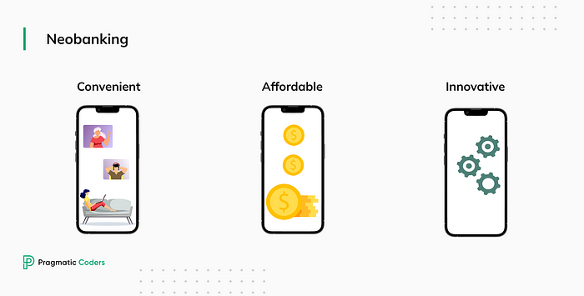

**5. Blockchain integration**

[Blockchain technology](https://www.pragmaticcoders.com/blog/all-you-need-to-know-about-blockchain) is not fading away; it’s becoming more embedded in [fintech products](https://www.pragmaticcoders.com/industries/fintech-software-development-services). Its transparency and security features make it essential for online financial processes. The three most promising uses of blockchain are:

* **Cross-border payments:**Blockchain-based solutions can process payments in seconds at a fraction of the cost of traditional methods.
* **Lending and borrowing:** decentralized lending and borrowing platforms eliminate the need for intermediaries while maintaining security.
* **Trade finance:** Blockchain can improve the efficiency and security of trade finance by reducing fraud and errors, as well as by enhancing transparency and traceability.

Blockchain integration is still in its early stages, but it is already having a major impact on the fintech industry. Expect it to drive down costs and increase accessibility to banking services in the upcoming years. Your transactions are about to become faster, cheaper, and more secure.

**6. Embedded finance**

Embedded finance is the integration of financial services into non-financial products and platforms. It is changing the way we think about payments, financing, and loans. Services like Buy Now, Pay Later (BNPL) are gaining traction, offering a seamless experience within non-financial platforms. This happens because they offer a number of advantages over traditional financial services:

* **Convenience:** Embedded finance is more convenient than traditional financial services because it is integrated into the products and platforms that people are already using. For example, a customer can apply for a BNPL loan at checkout without having to leave the retailer’s website.
* **Affordability:** Embedded finance can be more affordable than traditional financial services because it reduces the costs associated with customer acquisition and risk assessment.
* **Choice:** Embedded finance gives consumers more choices when it comes to financial services. For example, a customer can choose to pay for a purchase using a BNPL loan, a credit card, or a debit card.

Embedded finance is still in its early stages of development, but it is [growing rapidly](https://www.mckinsey.com/industries/financial-services/our-insights/embedded-finance-who-will-lead-the-next-payments-revolution). Fintech trends like this one put financial power in users’ hands, reducing reliance on traditional banks. In the near future, you’ll shop, pay, and borrow — all within your favorite fintech products.

**7. Financial inclusion initiatives**

Fintech companies are increasingly focused on bridging the financial inclusion gap. They’re using innovative technologies to make affordable financial services accessible to underserved populations. Some examples include:

**Mobile Banking:** Accessing financial services without visiting a physical branch is easier with mobile banking, benefiting underserved populations. Fintechs offer multilingual apps and features for low-income individuals.

**Digital Payments:** Affordable, secure, and user-friendly digital payment solutions are emerging from fintech companies. Digital wallets enable money transfers without requiring a bank account.

**Alternative Credit Scoring:** Fintechs develop non-traditional credit scoring models, considering factors like cash flow and mobile phone data, expanding loan access beyond traditional banks.

**Microfinance:** Fintechs extend microfinance loans to small businesses and entrepreneurs in underserved communities, fostering business growth and job creation.

Financial inclusion isn’t just a goal; it’s a commitment to leveling the playing field. Fintech companies are making significant progress in bridging the financial inclusion gap. However, there is still more work to be done in the upcoming years.

**Conclusions**

The fintech industry is constantly evolving, and new trends are emerging all the time. Fintechs will continue to make banking more secure, personalized, and accessible. They will remain the first to implement emerging technologies and ride the wave of innovation. The financial future is evolving, and it’s firmly in the hands of fintech pioneers.